**Spike:** 13

**Title:** Composite Pattern

**Author:** Ben Holmes, 103024841

**Goals / deliverables:**

* Update adventure world file and classes to allow entities composed of other entities, for example a bag with items in it.
* Commands that interact with these entities of entities:
  + LOOK IN
  + TAKE _ [FROM _]
  + PUT _ IN _
  + OPEN _ [WITH _]

**Technologies, Tools, and Resources used:**

* Visual studio 2022
* Word
* Spike 12 (as base)

**Tasks undertaken:**

* Plan the items (first bit in what we found out)
* Create entity child/subclasses
* Update Json to allow for these bags (and make the contents throughout the locations better test data)
* Update LOOK AT to account for same item in inventory and location (maybe different ids?)
* Make Look in
* Make new commands

**What we found out:**

Planned composite entities:

Bag:

* Doesn’t need opened
* Cant be locked
* Can be picked up

Pouch:

* Doesn’t need opened
* Can be locked
* Can be picked up

Barrel:

* Needs opened
* Cant be locked
* Cant be picked up

Chest:

* Needs opened
* Can be locked
* Cant be picked up

Will need 4 different subclasses considering the combination.

First was creation of the 4 subclasses

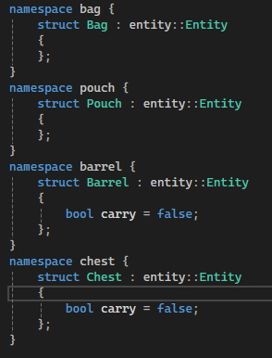

And there Json deserialise

They are all in different namespaces because if they aren’t the get<>() will not work properly as a result of them not overloading.

The differences between the 4 classes are what the values are preset as, and what values can be taken from the Json that aren’t the base id, name and description

|  |  |  |
| --- | --- | --- |
|  | preset | From Json |
| Bag | Open, carry, locked | inventory |
| Pouch | carry | Inventory, locked, open |
| Barrel | Carry, locked | Inventory, open |
| Chest | carry | Inventory, locked, open |

Next was the function to create contents/inventory:

This was collated so that I would not have to duplicate it for the graph and the player inventories. It is also done in such a way that it could be recursive (making inventories inside of inventories inside of inventories) by changing the Jsons for the bag and the like slightly (specific change noted in a comment in Entity.cpp)

I felt this was currently unnecessary on the creation side, added complexity for no real benefit, but you can put and take inventories from inside other inventories (cant access them though)



This was deliverable 1, with the rest being deliverable 2

Next was the LOOK IN command, an attachment to the LOOK command that was needed for testing so first priority.

The only difficulty was the fact I was allowing player to carry bags, so the look in had to account for both, which I did by creating a separate local function that took in the args, a target entity, and the adventure object. This was too prevent needing to duplicate the code for both player inventory and location contains.

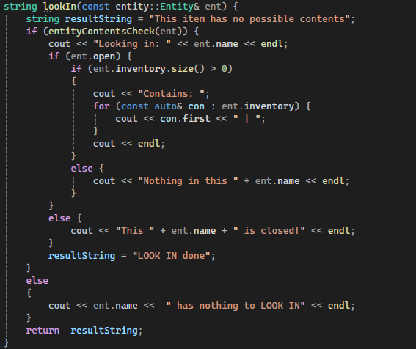

I used this format for the other 3 commands as well

Looking in bag in player inventory

Next was the adding of the new commands base and renaming all of the locations contents to inventories in the Json for ease of creation of the graph and player (location class still uses contains)

Also updated LOOK IN to account for object open.



Next was the creation of the Take command

This was surprisingly easy as I had already done something similar to the replace with the ALIAS command, so I had some code, and the rest was very similar to the LOOK/IN code

Take trinket from bag with surrounding look IN and Inventory commands to display

Open was next, only difficulty was getting the key check and figuring out exactly what Boolean logic was needed.

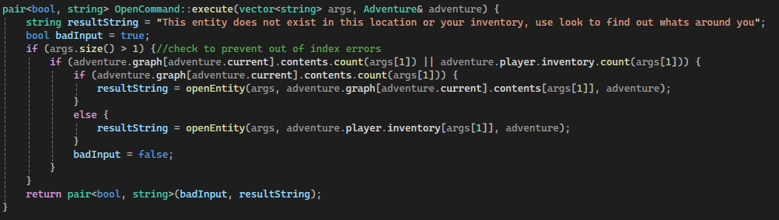

Put was last along with some improvements to the Json file (namely far better starting values with actual different things at each locations)

The only difficulty with Put was getting the erase/insert wrong on exactly with thing was being insert from where, resulting in blank data before I fixed it.

